**C-PROGRAMMING HOME WORK QUESTIONS AND ANSWERS**

**S.ABHISHEK**

**AM.EN.U4CSE19147**

**CSE – B BATCH**

**QUESTION : 1**

**SUM OF THE ELEMENTS IN THE ARRAY:**

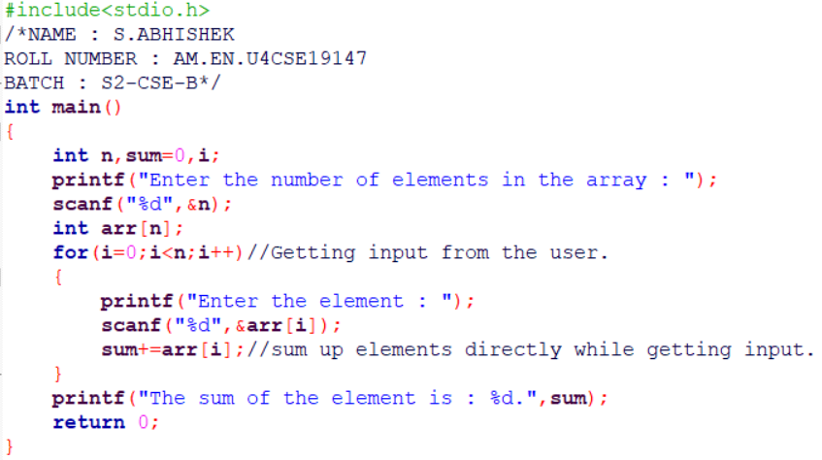

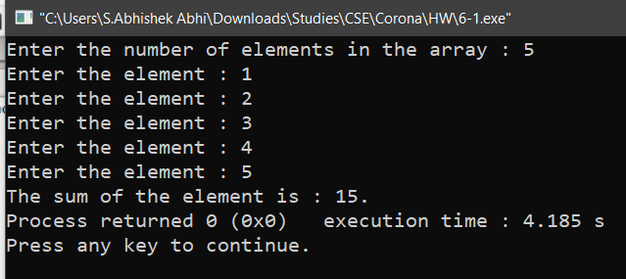

**QUESTION : 2**

**FIND THE SIZE OF THE ARRAY OF DIFFERENT DATA TYPES:**

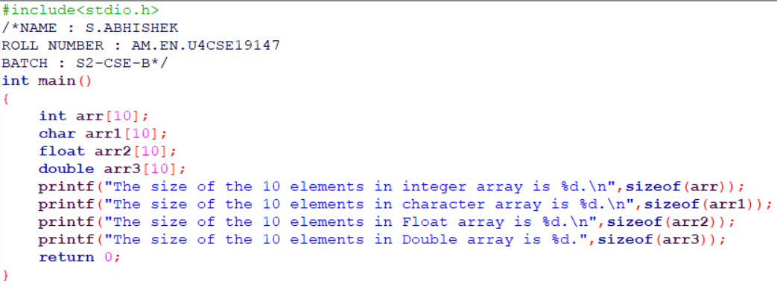

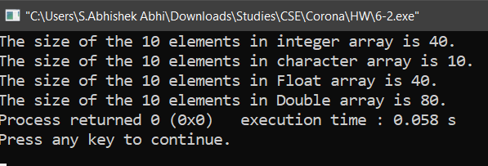

**QUESTION : 3**

**FIND NUMBER OF ELEMENTS IN THE ARRAY USING SIZEOF**( ) **FUNCTION :**

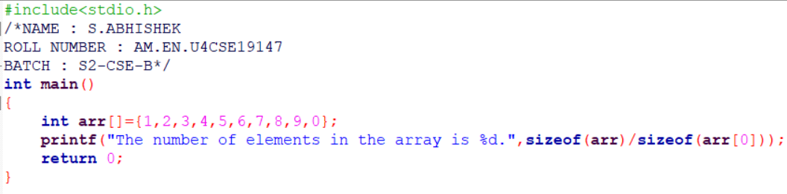

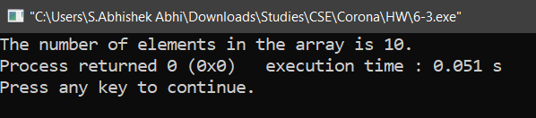

**QUESTION : 4**

**FIND THE SUM OF THE ELEMENTS IN THE ARRAY AND ADD 1 TO ALL ELEMENTS IN THE ARRAY :**

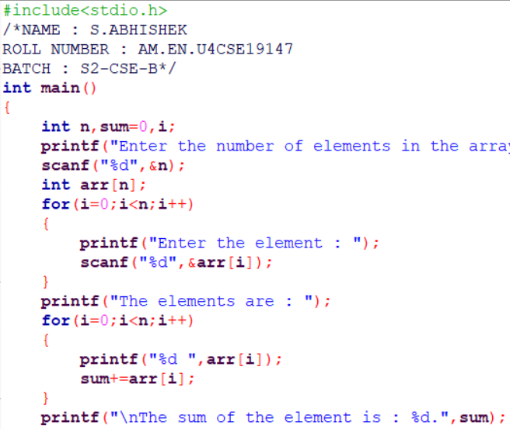

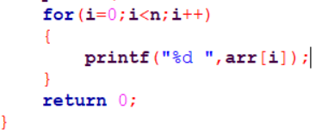

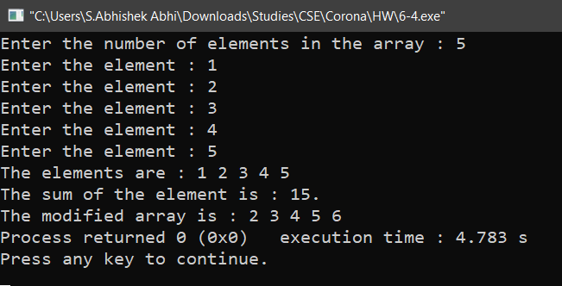

**QUESTION : 5**

**WORKING WITH POINTERS :**

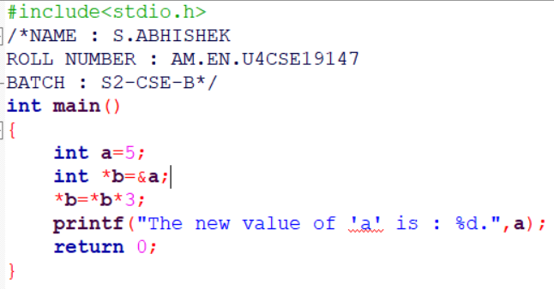

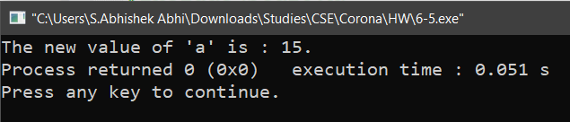

**QUESTION : 6**

**MULTIPLICATION WITH POINTERS :**

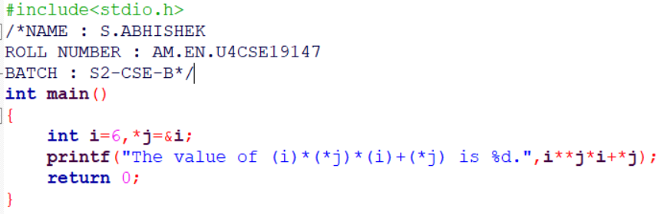

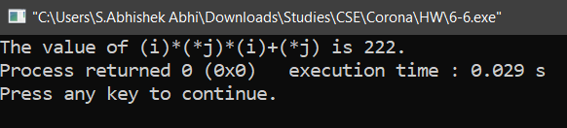

**QUESTION : 7**

**DISPLAY THE VALUE OF THE POINTER VARIABLE :**

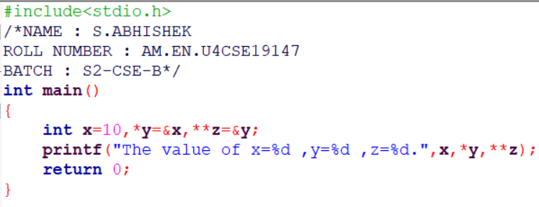

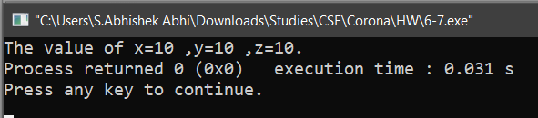

**QUESTION : 8**

**INPUT THE SIZE OF THE ARRAY FROM THE USER AND GET ‘N’ INPUTS AND DISPLAY IT :**

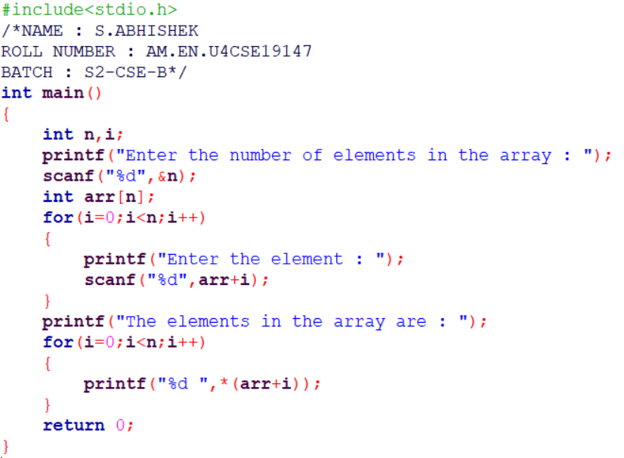

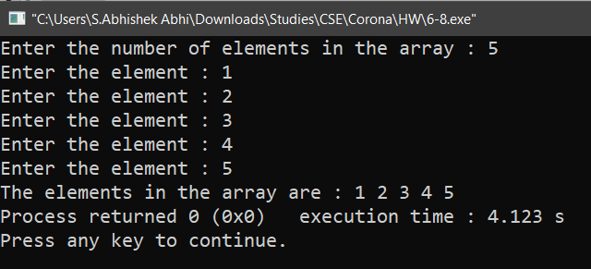

**QUESTION : 9**

**DISPLAY THE ARRAY ELEMENT USING THE POINTER :**

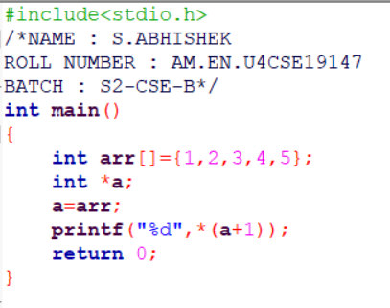

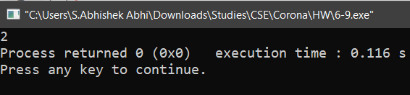

**QUESTION : 10**

**ADDING 1 TO ELEMENT IN THE ARRAY IF THE ELEMENT IS EVEN AND THE ELEMENT IS LESS THAN 30 AND ADDING 2 TO ELEMENT IN THE ARRAY IF THE ELEMENT IS ODD AND THE ELEMENT IS LESS THAN 30.**

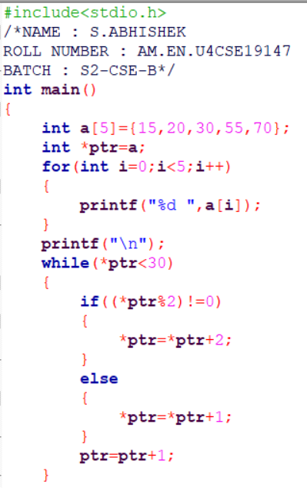

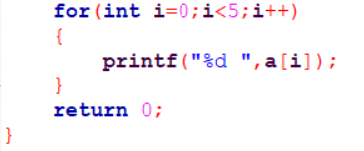

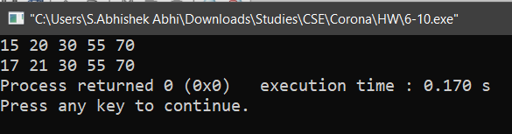

**QUESTION : 11**

**MULTIPLYING THE ELEMENT OF THE ARRAY BY TWO USING THE POINTER VALUE :**

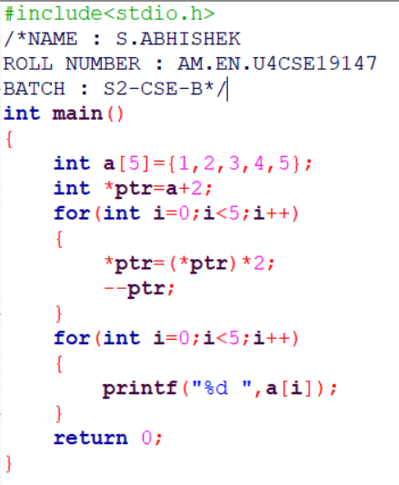

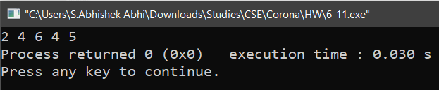

**QUESTION : 12**

**FIND THE POINTER VALUE AND DISPLAY IT:**

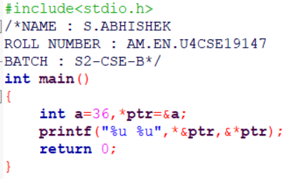

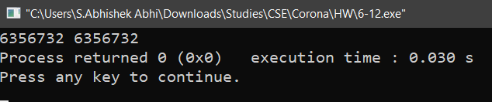

**QUESTION : 13**

**INPUT AN ARRAY AND GET AN INPUT FROM THE USER AND FIND WHETHER THE ELEMENT IS IN THE ARRAY OR NOT :**

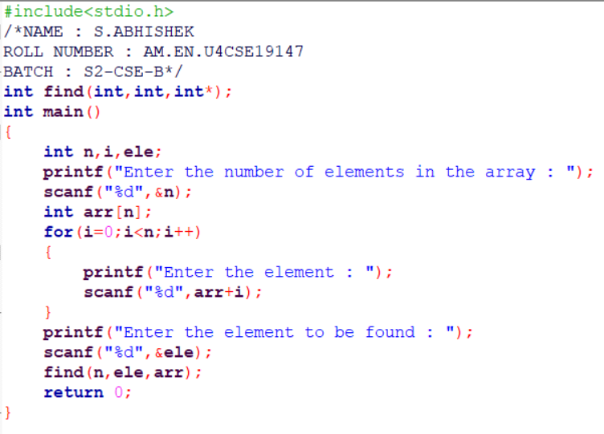

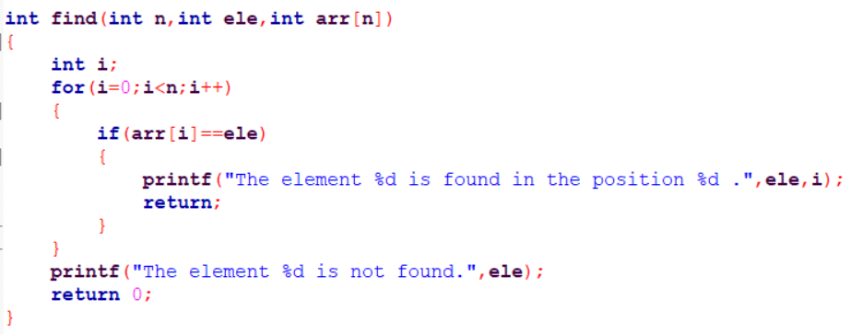

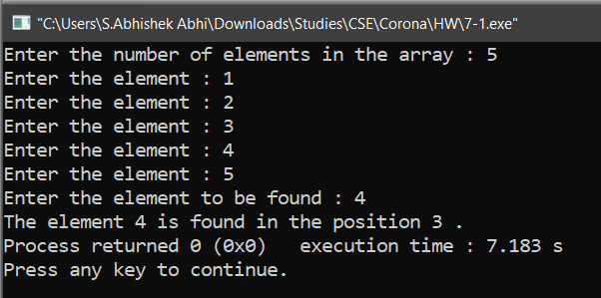

**QUESTION : 14**

**1 - GET INPUT FROM THE USER AND THE POSITION FROM WHICH IT HAS TO INSERTED AND SHIFT THE REMAINING ELEMENT ACCORDINGLY SO THAT THEIR ORDER IS NOT CHANGED.**

**2 – GET AN INPUT FROM THE USER AND DELETE THAT ELEMENT FROM THE ARRAY AND SHIFT REMAINING ELEMENTS IN THE ARRAY.**

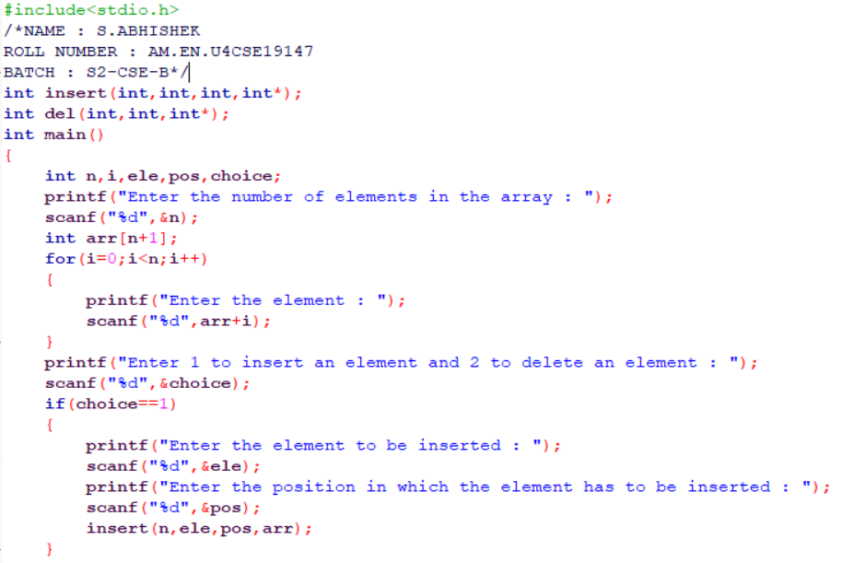

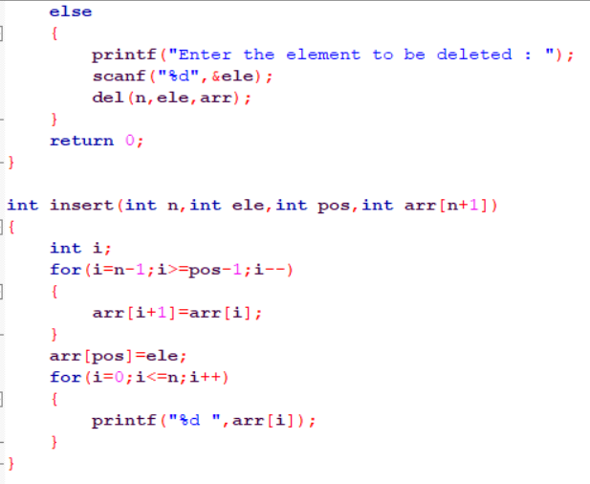

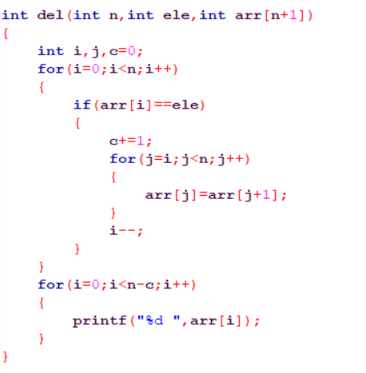

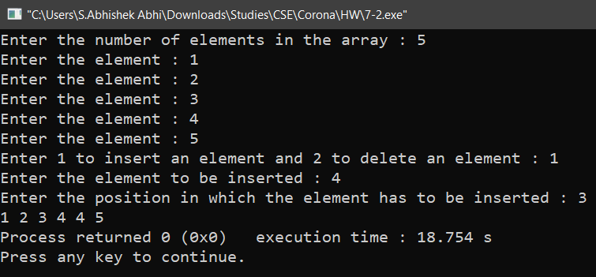

**QUESTION : 15**

**GET AN INPUT FROM THE USER AND DISPLAY THE PAIR OF THE ELEMENTS WHOSE SUM IS EQUAL TO THE INPUT.**

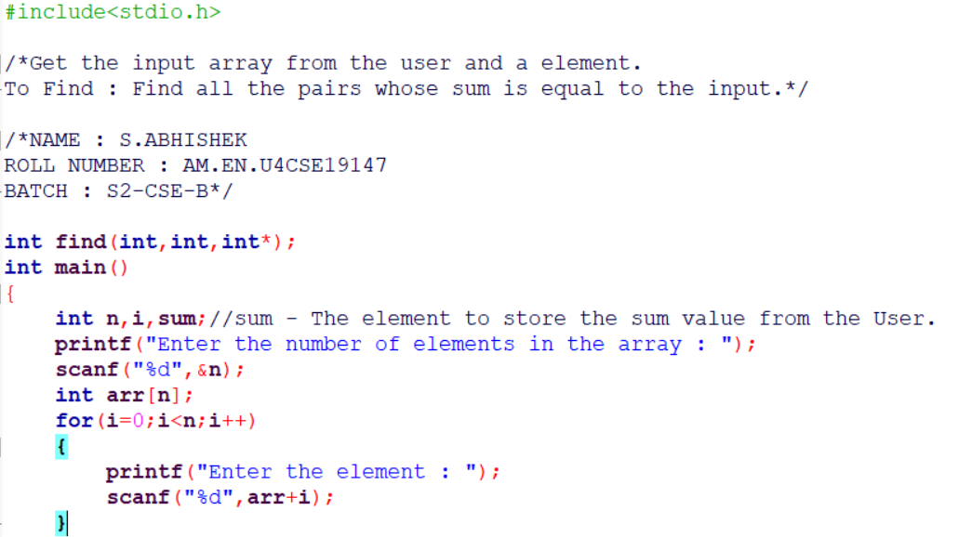

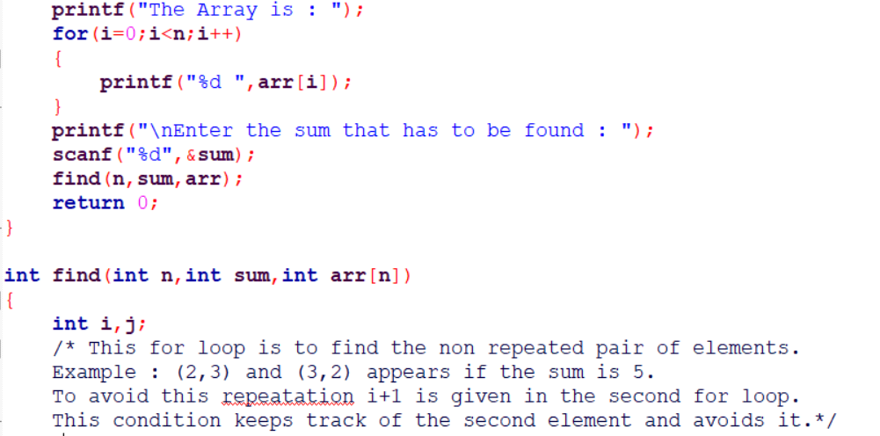

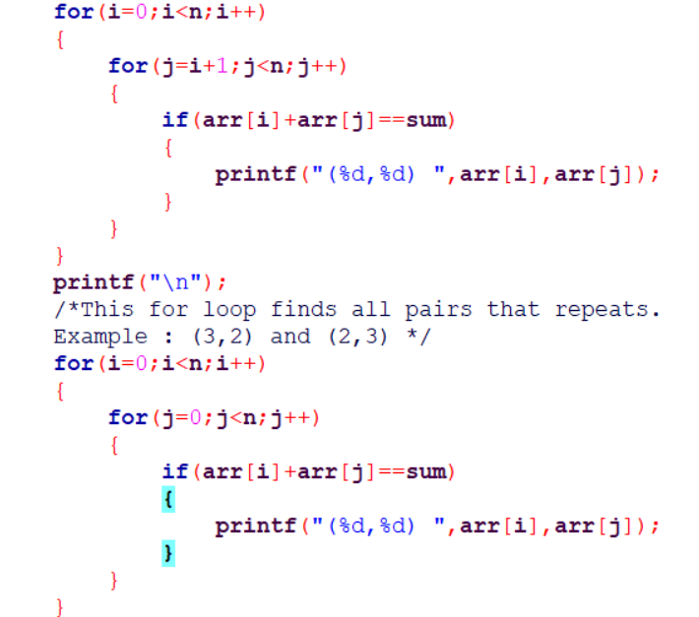

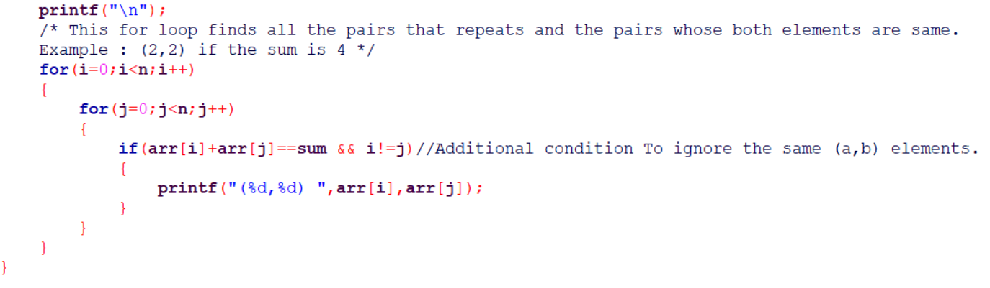

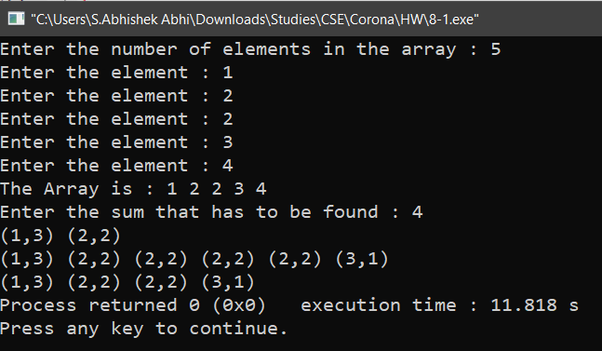

**QUESTION : 16**

**FIND DUPLICATE ELEMENTS IN THE ARRAY AND DELETE THEM FROM THE ARRAY :**

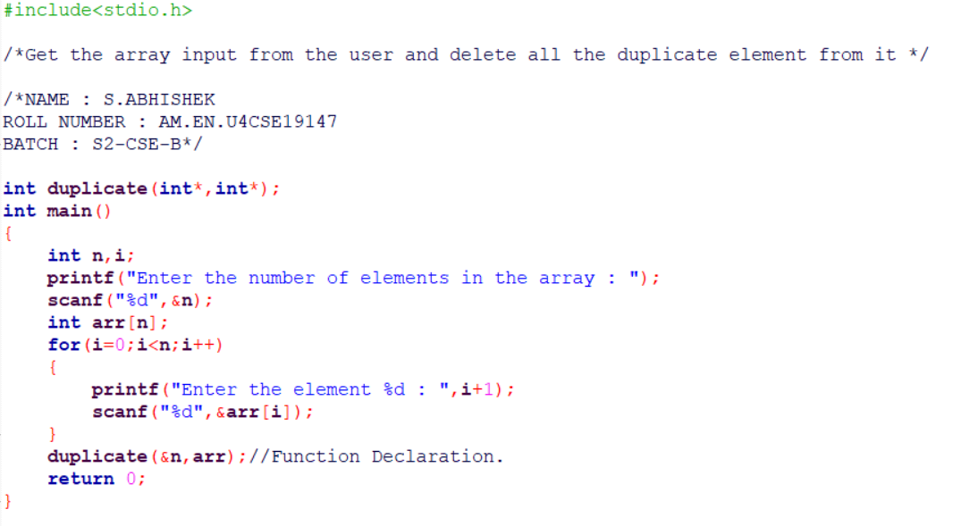

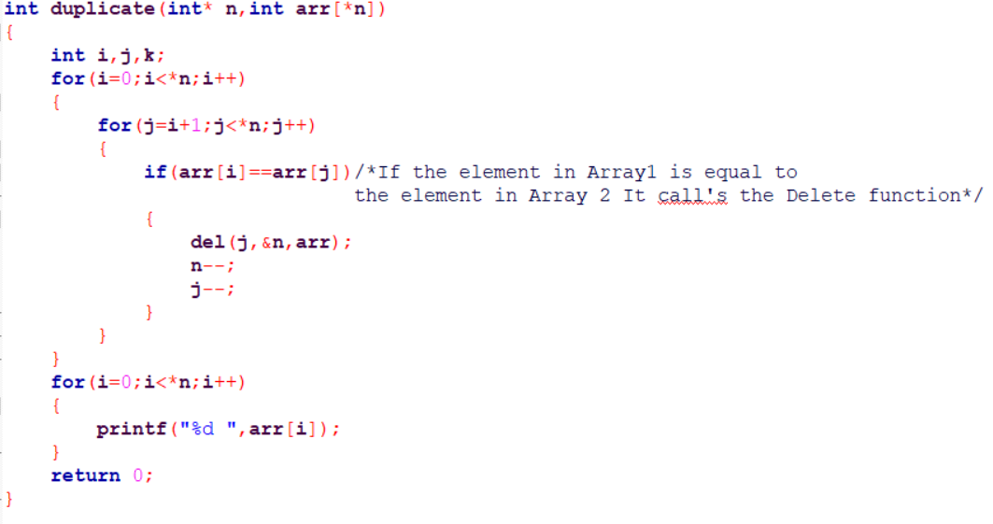

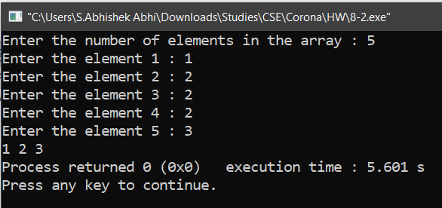

**QUESTION : 17**

**GET TWO SORTED ARRAY AS A INPUT FROM THE USER AND MERGE THAT TWO SORTED ARRAY INTO ONE SORTED ARRAY.( DON’T SORT AFTER MERGE ) :**

